LM + WebSmart ILE
Walkthrough Script

Last updated: June 21, 2012

Preliminary Info

- ALDM01 EXODUS51 subsystem must be running with EXSERV51 auto start job running in it.
  - STRSBS SBSD(XL_EX51/EXODUS51)
- ADMIN and WEBSMART must be running under QHTTPSVR
  - STRTCPSVR SERVER(*HTTP) HTTPSVR(WEBSMART)
  - Or you can do it from the web here (must sign in as security officer) http://172.25.8.113:2001/HTTPAdmin
- If your authorization to WebSmart IDE is expired,
  - get a new temp one from BCD
  - On ALDM01
  - addlible xl_weblib
  - unlock
  - paste in code.
- If you try to bring up the web site and it gives you a message “Could not connect to database: 08001”, it probably means that the password is not valid for the user profile in the preferences file in the IFS
  - on ALDM01, navigate the IFS to /esdi/websmart/v9.1/include/xl_user_preferences.php
  - locate the user profile and password and validate or change.
- Go to Firefox and open up the three tabs that show the various stages of the application and the LMi web portal:
  - Developer: http://172.25.8.113:8150/webapps/mulogin.pgm
  - QA http://172.25.8.113:8150/test/mulogin.pgm
  - Live PDN http://172.25.8.113:8150/live/mulogin.pgm
  - LMi web portal on ALDMO1
- Open up LMe 6.1a on PSG-LM and set preferences to AldonDemo/Wholesale/Base(1.0)
- Open up LMi on ALDMO1 and set preferences to Aldon/Wholesale/Base and developer WEBSMART

Walkthrough
- We are going to change the owner of the wholesale store on the main login page.
- Check out
  - (See task BCD05 for an easy checkout list)
  - RPG program MULOGIN to LMi developer WEBSMART
  - mulogin.pdw to Websmart-PSGDEV
- DC on the pdw to open up the WebSmart ILE IDE
- Change the name and save it. 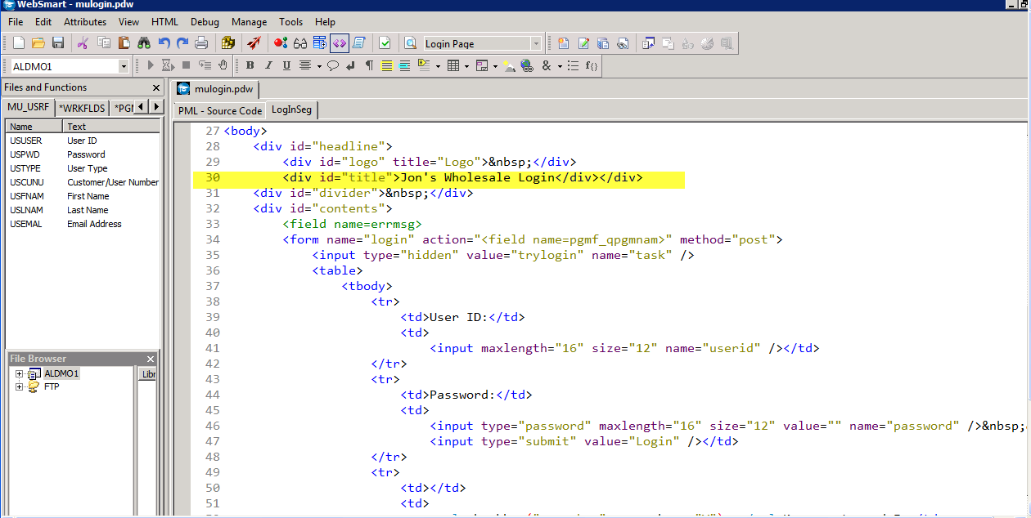
- Click on Attributes/Program
  - This is where WSILE will generate the ILE source and object
  - This is where we told LMi to check out the source and object to.
  - This is where LM is set up to promote from when we promote.
- Generate the program
- Refresh the development tab http://172.25.8.113:8150/webapps/mulogin.pgm You should see your changes.
- Return to LMe.
- Show the history of changes and the archiving on the pdw.
- Check in both the PDW and the RPG
  - This moves the pdw to QA (no deploy)
  - This promotes (no deploy) the RPG object to the QA library which drives the QA web site.
- Refresh the QA tab http://172.25.8.113:8150/test/mulogin.pgm and see changes.
- From LMe, Promote and deploy to Production.
- This will do a live deploy of the RPG code.
- Switch to the Web Portal and show changes happening to ALDMO1 via profile ALDWHOBASL.
- Show changed tab Live PDN http://172.25.8.113:8150/live/mulogin.pgm
- Switch to LMi.
- Show history of changes and source compare on the MULOGIN RPG.
- 5250 Xref:
  - Option 41 on MU-ORDHF
  - Show how it is tied to ORDERS
  - This means that whenever you change a PF, it can regenerate the WSILE code that is associated with it.
- Optional
  - Sign in to the website via admin/admin

